Boundary Value Analysis (BVA)

Definition
# Source: AI Source: Provided by: [Data Path: Persons Table -> ID Column: 1, Name_En Column: Motasem Essam] -> From: [ChatGPT] on [8/24/2025]
Boundary Value Analysis (BVA) is a black-box test design technique where you focus your tests on the edges (boundaries) of input ranges, because defects often occur at or just around those boundaries.

Key Idea
# Source: AI Source: Provided by: [Data Path: Persons Table -> ID Column: 1, Name_En Column: Motasem Essam] -> From: [ChatGPT] on [8/24/2025]
- Inputs are often restricted to certain ranges.
- Errors frequently occur when programmers use > instead of >=, or < instead of <=.
- So, instead of testing all values, you test:
  - Exactly at the boundary
  - Just below the boundary
  - Just above the boundary

Types of Boundary Value Analysis (BVA)

1. Structural Variations (based on which boundaries are tested)
# Source: AI Source: Provided by: [Data Path: Persons Table -> ID Column: 1, Name_En Column: Motasem Essam] -> From: [ChatGPT] on [8/24/2025]
Boundary Value Analysis (BVA) has three main types depending on how you select boundary points for testing.

1. Single Boundary Value Analysis
# Source: AI Source: Provided by: [Data Path: Persons Table -> ID Column: 1, Name_En Column: Motasem Essam] -> From: [ChatGPT] on [8/24/2025]
- You test only one side of the boundary for each range.
- Normally used when input has only one variable.
- You test:
  - The boundary value itself
  - The value just inside the boundary
  - The value just outside the boundary
Example – Age between 18–60:
Test values: 17 (just outside), 18 (boundary), 19 (just inside), 59, 60, 61.

2. Double (Two-Sided) Boundary Value Analysis
# Source: AI Source: Provided by: [Data Path: Persons Table -> ID Column: 1, Name_En Column: Motasem Essam] -> From: [ChatGPT] on [8/24/2025]
- You test both sides of each boundary for multiple variables.
- Used when there are two input variables and each has its own range.
- You test min, just above min, max, just below max for both variables.
Example – Age between 18–60, Salary between 3000–7000:
For Age: 17, 18, 19, 59, 60, 61
For Salary: 2999, 3000, 3001, 6999, 7000, 7001

3. Robust Boundary Value Analysis
# Source: AI Source: Provided by: [Data Path: Persons Table -> ID Column: 1, Name_En Column: Motasem Essam] -> From: [ChatGPT] on [8/24/2025]
- Like double BVA, but also includes values outside the valid domain to check how the system handles invalid inputs.
- Tests: Min−1, Min, Min+1, Max−1, Max, Max+1.
Example – Age between 18–60:
17 (Min−1), 18 (Min), 19 (Min+1), 59 (Max−1), 60 (Max), 61 (Max+1)

✅ Summary Table
# Source: AI Source: Provided by: [Data Path: Persons Table -> ID Column: 1, Name_En Column: Motasem Essam] -> From: [ChatGPT] on [8/24/2025]
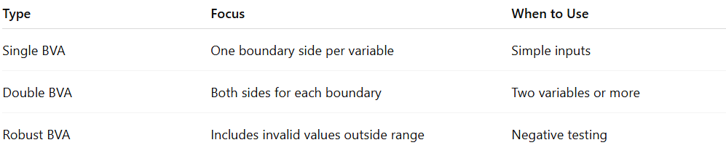
Type | Focus | When to Use
Single BVA | One boundary side per variable | Simple inputs
Double BVA | Both sides for each boundary | Two variables or more
Robust BVA | Includes invalid values outside range | Negative testing

2. Value-Count Variations (based on how many values are taken per boundary)

1- 2-Value BVA
# Source: AI Source: Provided by: [Data Path: Persons Table -> ID Column: 1, Name_En Column: Motasem Essam] -> From: [ChatGPT] on [8/24/2025]
- Tests the minimum and maximum values of an input range.
- You pick values at the boundary (exact edge) and sometimes just outside the boundary.
- Example: If valid input range = 1 to 100
  - Test values: 1, 100 (valid)
  - Plus 0, 101 (invalid, just outside the range).
This is the most common/simple version.

2- 3-Value BVA
# Source: AI Source: Provided by: [Data Path: Persons Table -> ID Column: 1, Name_En Column: Motasem Essam] -> From: [ChatGPT] on [8/24/2025]
- Adds an extra value inside the boundary.
- Tests the boundary, just below/above the boundary, and just inside the boundary.
- Example: If valid input range = 1 to 100
  - Lower boundary tests: 0, 1, 2
  - Upper boundary tests: 99, 100, 101
This gives stronger coverage because it checks both sides of the boundary and the immediate neighbor inside the range.

Example 1 – Age Requirement
# Source: AI Source: Provided by: [Data Path: Persons Table -> ID Column: 1, Name_En Column: Motasem Essam] -> From: [ChatGPT] on [8/24/2025]
- Rule: Age must be between 18 and 60.
- Boundaries: 18 and 60.
- BVA test values:
  - Lower boundary: 17 (just below), 18 (exact), 19 (just above)
  - Upper boundary: 59 (just below), 60 (exact), 61 (just above)

Example 2 – Postal Rate
# Source: AI Source: Provided by: [Data Path: Persons Table -> ID Column: 1, Name_En Column: Motasem Essam] -> From: [ChatGPT] on [8/24/2025]
- Rule:
  - 25p up to 10g
  - 35p up to 50g
  - 10p extra for each 25g up to 100g
- Boundaries: 10g, 50g, 75g, 100g.
- BVA test values:
  - 9g, 10g, 11g
  - 49g, 50g, 51g
  - 74g, 75g, 76g
  - 99g, 100g, 101g

✅ BVA vs Equivalence Partitioning (EP)
# Source: AI Source: Provided by: [Data Path: Persons Table -> ID Column: 1, Name_En Column: Motasem Essam] -> From: [ChatGPT] on [8/24/2025]
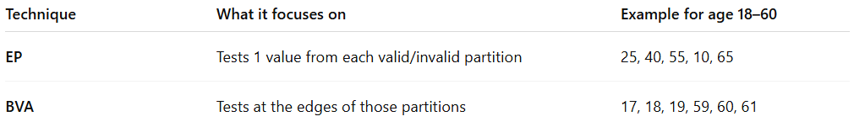
Technique | What it focuses on | Example for age 18–60
EP | Tests 1 value from each valid/invalid partition | 25, 40, 55, 10, 65
BVA | Tests at the edges of those partitions | 17, 18, 19, 59, 60, 61

Minimal BVA
# Source: AI Source: Provided by: [Data Path: Persons Table -> ID Column: 1, Name_En Column: Motasem Essam] -> From: [ChatGPT] on [8/24/2025]
Minimal BVA (Minimal Boundary Value Analysis) is a streamlined form of boundary value testing where you test only the minimum number of inputs needed to cover all boundaries — no extra “inside” or “outside” values beyond what’s strictly necessary.
It’s basically the smallest test set that still touches each boundary once.

Key Idea
# Source: AI Source: Provided by: [Data Path: Persons Table -> ID Column: 1, Name_En Column: Motasem Essam] -> From: [ChatGPT] on [8/24/2025]
- In standard BVA, you might test:
  - Just below the boundary
  - Exactly at the boundary
  - Just above the boundary
(for each boundary)
- In Minimal BVA, you pick only the essential ones that will cover all boundaries with the least redundancy.

Example
# Source: AI Source: Provided by: [Data Path: Persons Table -> ID Column: 1, Name_En Column: Motasem Essam] -> From: [ChatGPT] on [8/24/2025]
Rule: Age is valid between 18–60.
- Standard BVA:
17, 18, 19, 59, 60, 61 → 6 values
- Minimal BVA:
18 (lower bound), 60 (upper bound) → 2 values
(optionally 17 and 61 if you still want invalid coverage)

We choose 17 and 61 — not 19 and 59 — because of what boundaries mean in BVA

1️⃣ The goal of BVA
# Source: AI Source: Provided by: [Data Path: Persons Table -> ID Column: 1, Name_En Column: Motasem Essam] -> From: [ChatGPT] on [8/24/2025]
Boundary Value Analysis is about testing the edges of the valid range, not the middle.
We want to check:
- The first invalid value just outside the lower bound.
- The first invalid value just outside the upper bound.
That’s why:
- 17 is just below the valid minimum (18) → should be rejected.
- 61 is just above the valid maximum (60) → should be rejected.

2️⃣ Why not 19 or 59?
# Source: AI Source: Provided by: [Data Path: Persons Table -> ID Column: 1, Name_En Column: Motasem Essam] -> From: [ChatGPT] on [8/24/2025]
- 19 is inside the valid range, not touching a boundary.
- 59 is also inside the valid range, not touching a boundary.
- Testing them doesn’t prove the system handles the “edge” correctly — it only shows a “safe” middle value works.

3️⃣ Visual
# Source: AI Source: Provided by: [Data Path: Persons Table -> ID Column: 1, Name_En Column: Motasem Essam] -> From: [ChatGPT] on [8/24/2025]
Valid range: 18 → 60
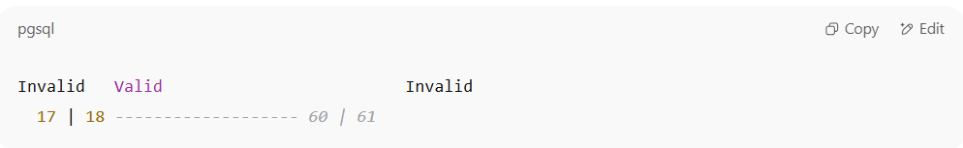
Invalid Valid Invalid
17 | 18 ------------------- 60 | 61

✅ Test: 17 (just outside lower bound), 18 (lower bound),
60 (upper bound), 61 (just outside upper bound)

What mean of lower bound and upper bound
# Source: AI Source: Provided by: [Data Path: Persons Table -> ID Column: 1, Name_En Column: Motasem Essam] -> From: [ChatGPT] on [8/24/2025]
Lower bound and upper bound are simply the smallest and largest values allowed in a valid range.

1️⃣ Definitions
# Source: AI Source: Provided by: [Data Path: Persons Table -> ID Column: 1, Name_En Column: Motasem Essam] -> From: [ChatGPT] on [8/24/2025]
- Lower bound → the minimum value that is still valid.
- Upper bound → the maximum value that is still valid.

2️⃣ Example: Age limit for a club
# Source: AI Source: Provided by: [Data Path: Persons Table -> ID Column: 1, Name_En Column: Motasem Essam] -> From: [ChatGPT] on [8/24/2025]
Valid ages: 18 to 60
- Lower bound = 18 (the smallest age allowed).
- Upper bound = 60 (the largest age allowed).

3️⃣ Visual
# Source: AI Source: Provided by: [Data Path: Persons Table -> ID Column: 1, Name_En Column: Motasem Essam] -> From: [ChatGPT] on [8/24/2025]
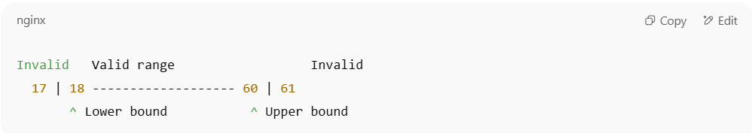
Invalid Valid range Invalid
17 | 18 ------------------- 60 | 61
^ Lower bound ^ Upper bound

4️⃣ Why they matter in testing
# Source: AI Source: Provided by: [Data Path: Persons Table -> ID Column: 1, Name_En Column: Motasem Essam] -> From: [ChatGPT] on [8/24/2025]
In Boundary Value Analysis (BVA), we focus on values right at or near these bounds because:
- Errors often happen at the edges (off-by-one bugs).
- They are the most likely points where input validation fails.

When to Use Minimal BVA
# Source: AI Source: Provided by: [Data Path: Persons Table -> ID Column: 1, Name_En Column: Motasem Essam] -> From: [ChatGPT] on [8/24/2025]
- When you want fast coverage with minimum tests.
- In smoke tests or early development when exhaustive testing isn’t practical.
- When boundaries are many and you want to avoid combinatorial explosion.

Coverage
# Source: AI Source: Provided by: [Data Path: Persons Table -> ID Column: 1, Name_En Column: Motasem Essam] -> From: [ChatGPT] on [8/24/2025]
Great follow-up 👌
In Boundary Value Analysis (BVA):
📌 Definition of Coverage
- The coverage items are the boundary values of equivalence partitions (valid and invalid).
- Coverage = the proportion of identified boundary values that are exercised by at least one test case.

📊 Formula
BVA Coverage (%)=Number of boundary values exercised by at least one test caseTotal number of identified boundary values×100\text{BVA Coverage (\%)} = \frac{\text{Number of boundary values exercised by at least one test case}}{\text{Total number of identified boundary values}} \times 100

✅ Example
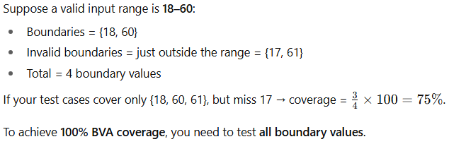
Suppose a valid input range is 18–60:
- Boundaries = {18, 60}
- Invalid boundaries = just outside the range = {17, 61}
- Total = 4 boundary values
If your test cases cover only {18, 60, 61}, but miss 17 → coverage = 34×100=75%\frac{3}{4} \times 100 = 75\%.
To achieve 100% BVA coverage, you need to test all boundary values.

👉 Difference from EP:
- EP coverage = making sure every partition has at least one representative test.
- BVA coverage = making sure every boundary value of those partitions is tested.

Perfect 👍 Let’s build a clear BVA coverage example step by step.

Example: Age Input Field
System accepts age between 18 and 60 (inclusive).

🔹 Step 1: Identify boundaries
- Valid boundaries: 18 (lower), 60 (upper)
- Invalid boundaries: 17 (just below lower), 61 (just above upper)
So total 4 boundary values.

🔹 Step 2: Create test cases
- Test case 1: 18 (valid lower boundary)
- Test case 2: 60 (valid upper boundary)
- Test case 3: 17 (invalid below range)
- Test case 4: 61 (invalid above range)

🔹 Step 3: Define coverage
Coverage items = all boundary values {17, 18, 60, 61}.
To achieve 100% BVA coverage, test cases must include all 4 values.

📊 Example Coverage Measurement
- Suppose you test only {18, 60, 61} → coverage = 3/4 = 75%
- If you test all {17, 18, 60, 61} → coverage = 4/4 = 100% ✅

👉 Key point:
- EP coverage = “Did I test each partition at least once?”
- BVA coverage = “Did I test each boundary value at least once?”

Great 👍 Let’s extend the same Age input (18–60 inclusive) example and show coverage under different BVA variations.

1️⃣ Single Boundary Value Analysis (Single BVA)
👉 Only one side of the range is tested (either lower or upper).
- Boundaries (choosing lower side): {18, 17}
- Total = 2 boundary values
Coverage Example:
- If you test {18 only} → 1/2 = 50% coverage
- If you test {18, 17} → 2/2 = 100% coverage

2️⃣ Double (Two-Sided) Boundary Value Analysis
👉 Both lower and upper sides are tested.
- Boundaries: {18, 60, 17, 61}
- Total = 4 boundary values
Coverage Example:
- If you test {18, 60} → 2/4 = 50% coverage
- If you test {18, 60, 17, 61} → 4/4 = 100% coverage

3️⃣ Robust Boundary Value Analysis
👉 Same as Double BVA plus invalid values just outside the range.
- Boundaries: {18, 60, 17, 61} (already includes invalids)
- Sometimes extended further (e.g., adding 16, 62 if “robust” means further outside).
Coverage Example:
- If only 18 and 60 tested → partial coverage
- If all {17, 18, 60, 61} tested → 100% coverage

4️⃣ Value-Count Variations (2-Value / 3-Value)
👉 Number of test values taken at each boundary.
- 2-Value → One valid + one invalid at each boundary
  - Lower side: {17, 18}
  - Upper side: {60, 61}
  - Total = 4 values
- 3-Value → One just below, one at, and one just above
  - Lower side: {17, 18, 19}
  - Upper side: {59, 60, 61}
  - Total = 6 values
Coverage Example:
- 2-Value → 4 values; coverage = tested / 4
- 3-Value → 6 values; coverage = tested / 6

✅ So, the coverage depends on which variation of BVA you apply and how many boundaries you include in your test set.

